Insertando imagen...

ACME-SF

G1.007

**Planning and progress report**

08/03/2024



# Cover

|  |  |
| --- | --- |
| **Repository:** <https://github.com/DP2-C1-07/Acme-SF-D01> | |
| **Student #1**  **ID:** 31878881F  **UVUS:**  pabcabmar3  **Name:** Caballero María, Pablo **Roles:** manager, developer | **Student #2**  **ID Number:**49034820Q  **UVUS:** mararnmon  **Name:** Arnáiz Montero, Marco Antonio  **Roles:** developer, operator |
| **Student #3**  **ID Number:** 77865211E  **UVUS:**  alfalolan  **Name:** Alonso Lanzarán, Alfonso Luis  **Roles:** developer, tester | **Student #4**  **ID Number:** 53932912M  **UVUS:** albsanmim  **Name:** Sánchez Mimbrero, Alberto  **Roles:** developer |
| **Student #5**  **ID Number:** 48123111G  **UVUS:** juagarcar4  **Name:** Garcia Carballo, Juan  **Roles:** developer |  |

Table of contents

Cover 2

Executive summary 2

Revision table 2

Introduction 3

Contents 3

Planning chapter: 3

Progress chapter 5

Conclusions 5

Bibliography 5

# Executive summary

Revision table

|  |  |  |
| --- | --- | --- |
| Number | Date(dd/mm/yyyy) | Description |
| 1.0 | 08/03/2024 | Document done in its entirety |

# Introduction

The purpose of this document is to provide a detailed planning and progress report of the second delivery of the project “Acme-SF-D01”, for the subject “Design and Testing 2”. This is divided into two chapters: planning (specifying the requirements set for this delivery, assignees, roles, planned time, actual time, budget estimation...) and progress (assignees performances, conflicts arisen, actual cost in contrast to the estimations...).

This document has an executive summary, a revision table where there are versioned records, this introduction, the main content (divided into a planning, and a progress chapter), and the conclusions of the report.

# Contents

## Planning chapter:

List of taks for the second deliverable:

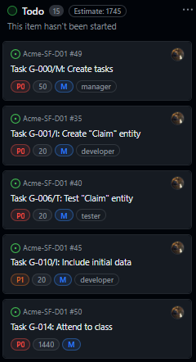

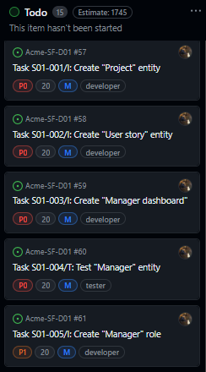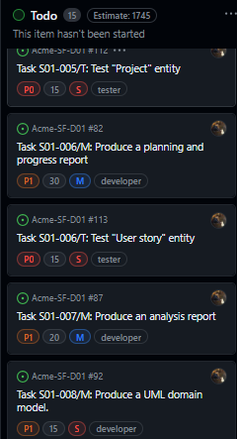

Next, there are screenshots that shows different moments of the delivery development.

Beginning:



Middle:

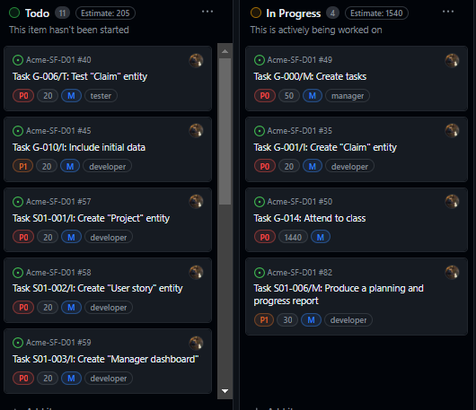

End:

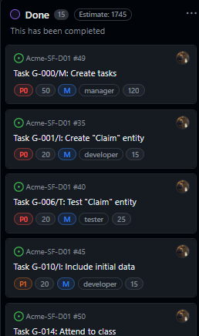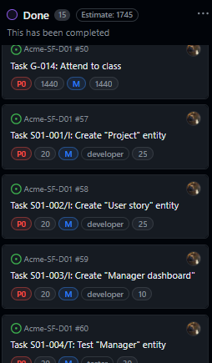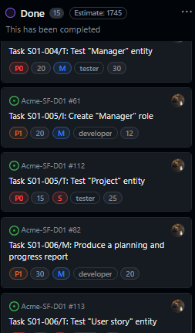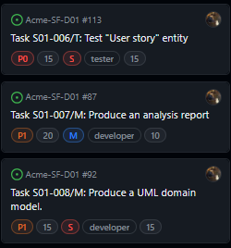

Next, it is shows the calculation of the estimated budget:

|  |  |  |  |  |
| --- | --- | --- | --- | --- |
| Title | Assignees | Status | Estimate | Role |
| Task G-000/M: Create tasks | Pablo-Caballero-Maria | Done | 1 | manager |
| Task G-001/I: Create "Claim" entity | Pablo-Caballero-Maria | Done | 1 | developer |
| Task G-010/I: Include initial data | Pablo-Caballero-Maria | Done | 1 | developer |
| Task S01-001/I: Create "Project" entity | Pablo-Caballero-Maria | Done | 1 | developer |
| Task G-006/T: Test "Claim" entity | Pablo-Caballero-Maria | Done | 1 | tester |
| Task S01-007/M: Produce an analysis report | Pablo-Caballero-Maria | Done | 1 | developer |
| Task S01-005/I: Create "Manager" role | Pablo-Caballero-Maria | Done | 1 | developer |
| Task S01-005/T: Test "Project" entity | Pablo-Caballero-Maria | Done | 1 | tester |
| Task S01-002/I: Create "User story" entity | Pablo-Caballero-Maria | Done | 1 | developer |
| Task S01-006/T: Test "User story" entity | Pablo-Caballero-Maria | Done | 1 | tester |
| Task S01-003/I: Create "Manager dashboard" | Pablo-Caballero-Maria | Done | 1 | developer |
| Task S01-004/T: Test "Manager" entity | Pablo-Caballero-Maria | Done | 1 | tester |
| Task G-014: Attend to class | Pablo-Caballero-Maria | Done | 24 | tester |
| Task S01-008/M: Produce a UML domain model. | Pablo-Caballero-Maria | Done | 1 | developer |
| Task S01-006/M: Produce a planning and progress report | Pablo-Caballero-Maria | Done | 1 | developer |

Total cost for tasks = 770 €

Equipment cost = 700 €

Considering a lineal amortization over 3 years, the yearly amortization cost is 490 €

## Progress chapter

Progress records:

Member: Pablo Caballero María

Performance indicators: Total tasks done/total tasks to do ratio is 1, which is considered “good” according to the chartering report. Along these lines, I will be granted the privilege to choose the role for the next delivery.

No conflicts whatsoever arose during the progress of this delivery.

Next, there is a table showing the actual budget consumed by the project:

|  |  |  |  |  |
| --- | --- | --- | --- | --- |
| Title | Assignees | Status | Invested time | Role |
| Task G-000/M: Create tasks | Pablo-Caballero-Maria | Done | 2 | manager |
| Task G-001/I: Create "Claim" entity | Pablo-Caballero-Maria | Done | 1 | developer |
| Task G-010/I: Include initial data | Pablo-Caballero-Maria | Done | 1 | developer |
| Task S01-001/I: Create "Project" entity | Pablo-Caballero-Maria | Done | 1 | developer |
| Task G-006/T: Test "Claim" entity | Pablo-Caballero-Maria | Done | 1 | tester |
| Task S01-007/M: Produce an analysis report | Pablo-Caballero-Maria | Done | 1 | developer |
| Task S01-005/I: Create "Manager" role | Pablo-Caballero-Maria | Done | 1 | developer |
| Task S01-005/T: Test "Project" entity | Pablo-Caballero-Maria | Done | 1 | tester |
| Task S01-002/I: Create "User story" entity | Pablo-Caballero-Maria | Done | 1 | developer |
| Task S01-006/T: Test "User story" entity | Pablo-Caballero-Maria | Done | 1 | tester |
| Task S01-003/I: Create "Manager dashboard" | Pablo-Caballero-Maria | Done | 1 | developer |
| Task S01-004/T: Test "Manager" entity | Pablo-Caballero-Maria | Done | 1 | tester |
| Task G-014: Attend to class | Pablo-Caballero-Maria | Done | 24 | tester |
| Task S01-008/M: Produce a UML domain model. | Pablo-Caballero-Maria | Done | 1 | developer |
| Task S01-006/M: Produce a planning and progress report | Pablo-Caballero-Maria | Done | 1 | developer |

Total cost for tasks = 800 €

Equipment cost = 700 €

Considering a lineal amortization over 3 years, the yearly amortization cost is 500 €

Comparing, we can calculate that yearly cost would be a 2.04% than the cost that was estimated.

# Conclusions

The planning of tasks was done using GitHub projects. In this delivery, creating the task took more time than I had thought, because I had to create a lot of tasks for testing. Also, in this delivery, we considered the cost of tasks in hours, rounding to the nearest integer greater than 0.

# Bibliography

Intentionally blank.